JUNE 29 – MEETING 26
VOLUME 29

The Ross County Board of Commissioners met on this day, June 29, 2026, in regular session.

Commissioner Jack Everson called the meeting to order at 9:00 a.m., with Commissioner James Lowe and David Glass, in attendance.

Commissioner Everson led the Pledge of Allegiance.

MINUTES APPROVED
Mr. Lowe moved, Mr. Glass seconded, the minutes of the June 22, 2026 meeting, be approved as submitted. On call of the roll, the vote was:

Mr. Glass, yes; Mr. Lowe, yes; Mr. Everson, yes. Motion carried.

BILLS APPROVED FOR PAYMENT
Mr. Lowe moved, Mr. Glass seconded, the following bills of the county be approved for payment:

On call of the roll, the vote was: Mr. Glass, yes; Mr. Lowe, yes; Mr. Everson, yes. Motion carried.

THEN & NOW CERTIFICATES APPROVED
Mr. Lowe moved, Mr. Glass seconded, the Ross County Board of Commissioners approve "Then & Now" Certificates, dated June , 2026 through March 23, 2026, in the amount of $168,499.04 prepared by the Office of the Ross County Auditor and certified by the auditor as to the appropriation of funds for the purpose of encumbering the sum of the contract(s) or order(s) outlined therein, or the
imminent collection of funds for credit to the appropriated fund(s) of the county, and as to the availability of funds for transfer within the appropriate department(s).

On call of the roll, the vote was: Mr. Lowe, yes; Mr. Glass, yes; Mr. Everson, yes. Motion carried.

TRANSFER OF FUNDS
Mr. Lowe moved, Mr. Glass seconded, to transfer $110,000.00 from account code 650-01-00-7104 UHS ARPA Funds, into account code 650-04-00-7103 MS Consultants ARPA Funds, per a request of March 23, 2026 from the Ross County Commissioners.

On call of the roll, the vote was: Mr. Glass, yes; Mr. Lowe, yes; Mr. Everson, yes. Motion carried.

Mr. Lowe moved, Mr. Glass seconded, to transfer $1,200.00 from account code 100-21-00-7151 Supplies Forensic, into account code 100-21-00-7100 Travel, per a request of March 23, 2026 from the Ross County Coroner.

On call of the roll, the vote was: Mr. Lowe, yes; Mr. Glass, yes; Mr. Everson, yes. Motion carried.

ASSET DISPOSAL

Mr. Lowe moved, Mr. Glass seconded, the Ross County Board of Commissioners approve an Asset Disposal Form submitted by the Ross County Clerk of Courts for disposal of the following surplus property of the county as indicated:

QUANTITY DESCRIPTION TAG/SERIAL # METHOD OF DISPOSAL

1 Micro Wave 07883 Surplus Property
On call of the roll, the vote was: Mr. Glass, yes; Mr. Lowe, yes; Mr. Everson, yes. Motion carried.

TIME SHEET APPROVED COUNTY ADMINISTRATOR
Mr. Lowe moved, Mr. Glass seconded, the Ross County Board of Commissioners approve the time sheet submitted by Bradford M. Cosenza, County Administrator for the pay period ending June 27, 2026.

On call of the roll, the vote was: Mr. Glass, yes; Mr. Lowe, yes; Mr. Everson, yes. Motion carried.

PUBLIC HEARING NOTICE COMPREHENSIVE PLAN

Mr. Glass moved, Mr. Lowe seconded, to approve a public hearing notice for the comprehensive plan, August 24, 2026 at 9:30am in the Commissioner Conference room.

On call of the roll, the vote was: Mr. Lowe, yes; Mr. Glass, yes; Mr. Everson, yes. Motion carried.

ADDENDUM TO COMMUNITY BASED CORRECTIONS SUBSIDY GRANT AGREEMENT

Mr. Lowe moved, Mr. Glass seconded, to sign the addendum between the State of Ohio, Department of Rehabilitation and Correction, and Ross County to amend the original fiscal year 2026/2027 Community Corrections Grant Agreement to modify the award amounts as listed below and add paragraphs 27 and 28:

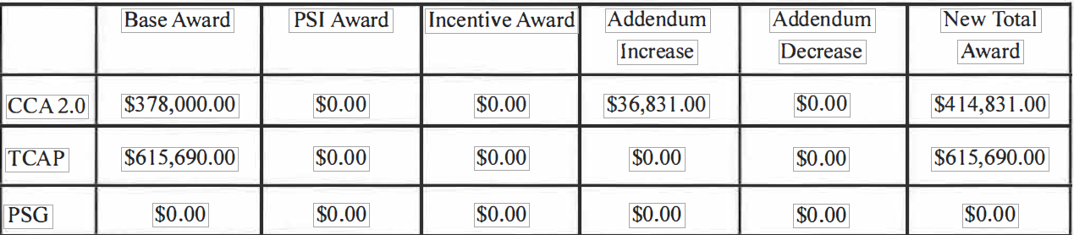

27. Liability: To the extent allowable by law, each party agrees to be responsible for any liability, suits, losses, judgments, damages, or other demands brought as a result of its own negligent actions or omissions in the performance of this Agreement.

28. Civil Rights Assurance: The parties hereby agree that they will comply with Title VI of the Civil Rights Act of 1964 (42 U.S.C. § 2000d et seq.) and the Age Discrimination Act of l975 (42 U.S.C. § 6101 et seq.).

On call of the roll, the vote was: Mr. Glass, yes; Mr. Lowe, yes; Mr. Everson, yes. Motion carried.

AMENDMENT 1 ACGP GRANT AGREEMENT VILLAGE OF GEORGETOWN

Mr. Glass moved, Mr. Lowe seconded, to approve an amendment to the ACGP grant agreement between Ross County and the Village of Georgetown. The Department of Development increased the project award by $115,000 for the US Grant Visitor Center for a canopy for the outdoor areas of the US Grant Visitor Center, and for foundation repairs to the Visitor Center.

On call of the roll, the vote was: Mr. Lowe, yes; Mr. Glass, yes; Mr. Everson, yes. Motion carried.

AMENDMENT 1 ACGP GRANT AGREEMENT BELMONT PORT AUTHORITY

Mr. Lowe moved, Mr. Glass seconded, to approve an amendment to the ACGP grant agreement between Ross County and the Belmont Port Authority. The Department of Development increased the project award by $50,00 for the Black Horse Inn for the scope of work inclusion of structural repairs to the Black Horse Inn.

On call of the roll, the vote was: Mr. Glass, yes; Mr. Lowe, yes; Mr. Everson, yes. Motion carried.

OTHER BUSINESS

Work Session

ADJOURN
Mr. Jack A. Everson, President, adjourned the regular meeting of June 29, 2026, at am, Board of Commissioners of Ross County, Ohio
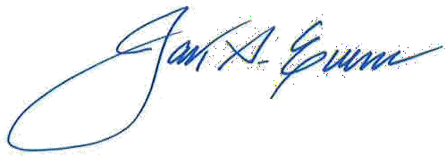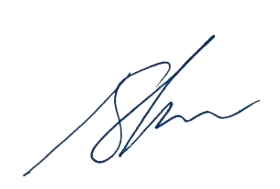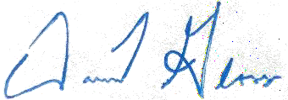
Jack A. Everson, President

James E. Lowe, Vice President
David Glass, Commissioner

